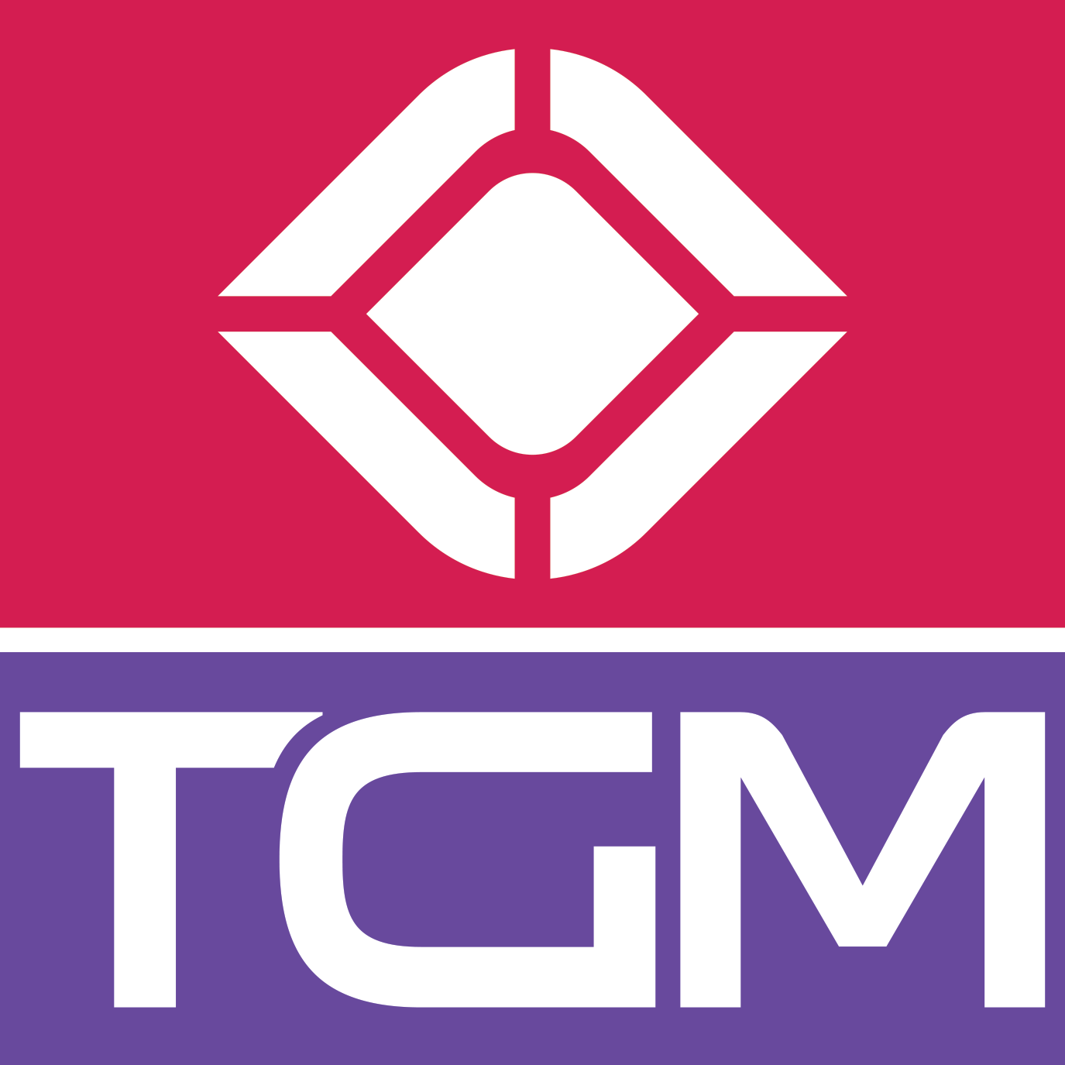

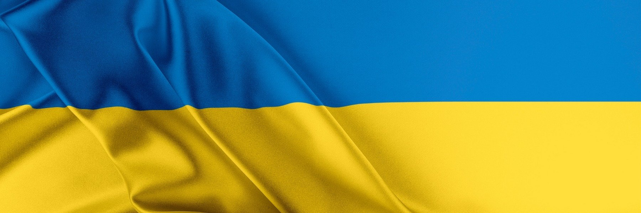

Warsaw, Poland March 1, 2022
TGM Research Releases Largest Survey Report Revealing the World’s Reaction to Russia-Ukraine Conflict

Noted data and insights company TGM Research has just revealed the findings of its interactive survey on people’s perception of the current situation in Ukraine. As part of this survey, 10,204 respondents from France, Germany, Hungary, Italy, Poland, Romania, United Kingdom and the United States were interviewed online.

Russia launched a full-scale invasion of Ukraine on February 24th, killing dozens and forcing hundreds to flee for their lives. Russian air strikes hit military facilities across the country and ground forces moved in from the north, south and east, triggering condemnation from political leaders as well common people around the world.

Immediately after the start of the conflict, Warsaw-based data and insights company TGM Research started a comprehensive multi-country survey involving 10,204 participants from France, Germany, Hungary, Italy, Poland, Romania, United Kingdom and the United States. The objective of this survey was to find out what the world feels about this unprecedented act of terror.

The survey by TGM Research is the largest survey conducted since the breakout of the Russia-Ukraine conflict. This survey was carried out between the 25th and the 26th of February, 2022 using internet-based polling on a representative sample of 18+. In this terrifying situation of social anxiety, the findings of this survey provides a clear indication of the common people’s stand about the current situation in Ukraine.

Mentioned below are some of the most important findings of the survey at a glance.

- In most of the countries, a high percentage of people are familiar with the current situation in Ukraine
- Nearly 80% of respondents mentioned that the conflict is a matter of threat for the European as well as their country’s security.
- 2 out of 3 Europeans are willing to help Ukrainian refugees by conducting fundraisers, preparing apartments, and collecting food and clothes for them.
- In the present scenario, around 17% respondents don’t feel safe in their respective countries, about 35% feel this situation could lead to World War III, and 65% consider ongoing refugee problem to be the greatest concern resulting from this situation.
- Approximately 40% people feel their country is making right decisions in supporting Ukraine and more than 70% are in favor of their countries accepting Ukrainian refugees.
- 37% of people believe that NATO should send military support for Ukraine.
- Approximately 25% people feel that EU has reacted sufficiently in this situation.
- More than 50% are in favor of a trade sanction for Russia and boycott of Russian goods.
- 51% of participants want EU to completely block trade exchange with Russia.
- 45% are in favor of facilitating the refugee process for Ukrainian citizens.

Being close to each other for centuries with common history and geography, individuals from European nations are showing extraordinary solidarity towards Ukraine in these tough times. TGM Research has done well to capture the emotions of the common people from 7 European countries and the US about the ongoing crisis. Most importantly, the survey clarifies the fact that there is no social consent whatsoever for Russia’s attack on Ukraine.

“The Conflict between Russia and Ukraine is threatening world security and causing an ongoing refugee problem. However, our Europeans are strongly supporting Ukraine and the majority is willing to help as our survey shows. Many of them have friends or loved ones and feel connected to Ukraine,” said Greg Laski, the CEO of TGM Research.

The entire survey report released by TGM Research is now available at https://tgmresearch.com/war-in-ukraine-2022-global-survey-results.html

More info about global survey projects at tgmresearch.com

About TGM Research:
TGM Research is an international technology-driven market research agency, which uses innovative digital ways to conduct surveys. We deliver large-scale global projects across all business and consumer audiences. Our global team of consultants blends people expertise and technology experiences to build insight solutions that help drive our clients’ incremental growth.

Contact:

Sławek Wilski /Partner
E-mail: slawek@tgmresearch.com

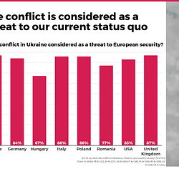 | 1.Russia-Ukraine-war-considered-as-a-threat-to-status-quo-TGM-Research.png | Download
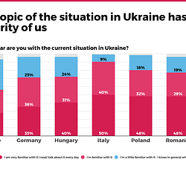 | 1b-Russia-Ukraine-war-has-moved-us-all-TGM-Research-Survey.png | Download
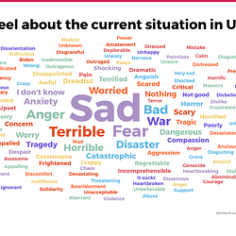 | 2.What-emotions-Russian-Ukraine-War-evoke-TGM-Research-Survey.png | Download
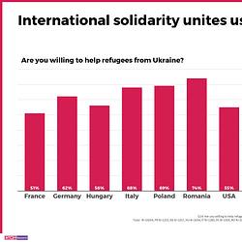 | 4.Strong-willingness-to-support-refugees-TGM-Research-Survey.png | Download
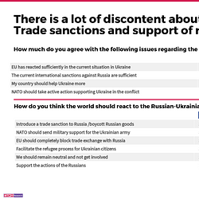 | 3.What-kind-of-reactions-should-governments-take-TGM-Research-survey.png | Download
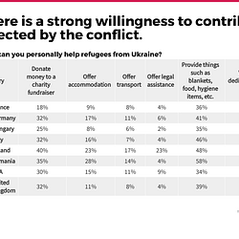 | 5.Societies-are-willing-to-support-TGM-Research-Survey.png | Download

